EXPERIMENT-05
Aim: Create a content provider to manage and share data between different components of your android application.
To manage and share data between different components of your Android application, you can implement a ContentProvider. A ContentProvider acts as an abstraction layer over your app’s data sources (like SQLite databases, files, or even network data) and provides a standard interface for other components or apps to query and modify that data.
Theory:
A Content Provider is an Android component used to manage and share data between applications. It provides a structured interface to access data using URIs and supports operations like insert, query, update, and delete.

- Create Content Provider Class
  - Open Android Studio
  - Right-click package → New → Java Class → MyProvider
● Extend ContentProvider class
● Implement methods:
○ onCreate() → Initialize data (ArrayList with names)
○ query() → Return data using MatrixCursor
○ insert() → Add new data to list
○ delete() → Clear all data
○ update() and getType() → default return
- Register Provider
  - Add in AndroidManifest.xml:
<provider android:name=".MyProvider" android:authorities="com.example.provider" android:exported="true"/>
- Design Layout
  - In activity_main.xml, add:
○ EditText → Enter name
○ Button → Insert
○ Button → Show Data
- Implement MainActivity
  - Initialize views using findViewById()
● Define URI:
Uri uri = Uri.parse("content://com.example.provider");

  - Insert Button:
○ Use ContentValues
○ Call getContentResolver().insert()
● Show Button:
○ Use query()
○ Read data using Cursor
○ Display using Toast
- Run Application
  - Enter name → Click Insert
  - Click Show Data → Display stored names

Code:
MyProvider.java
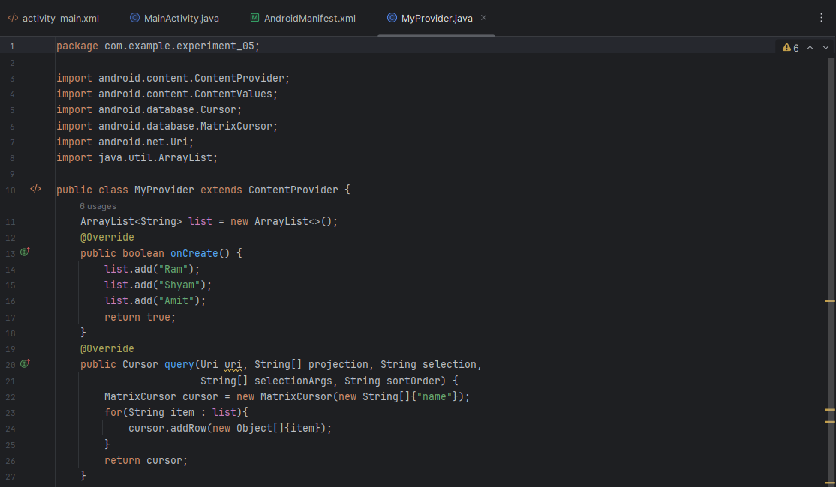
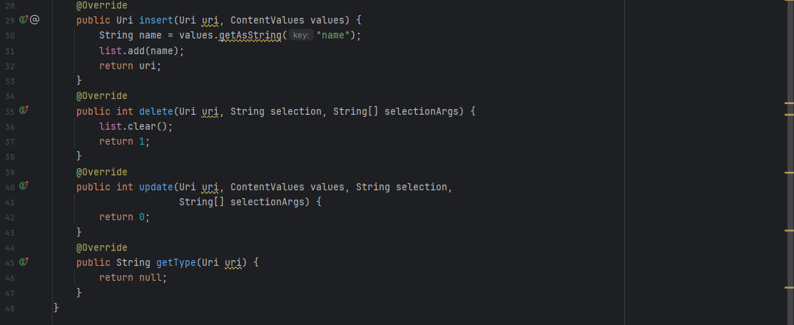

activity_main.xml
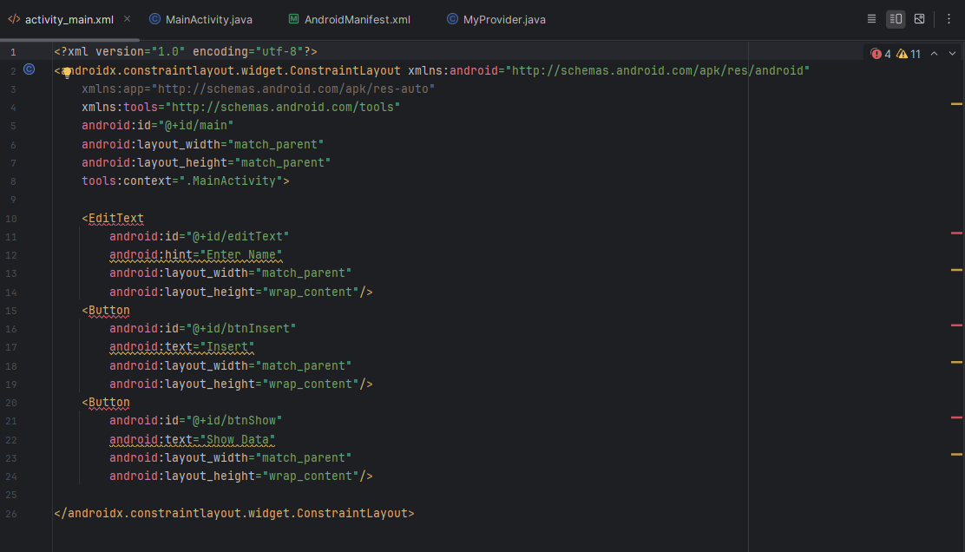

MainActivity.java
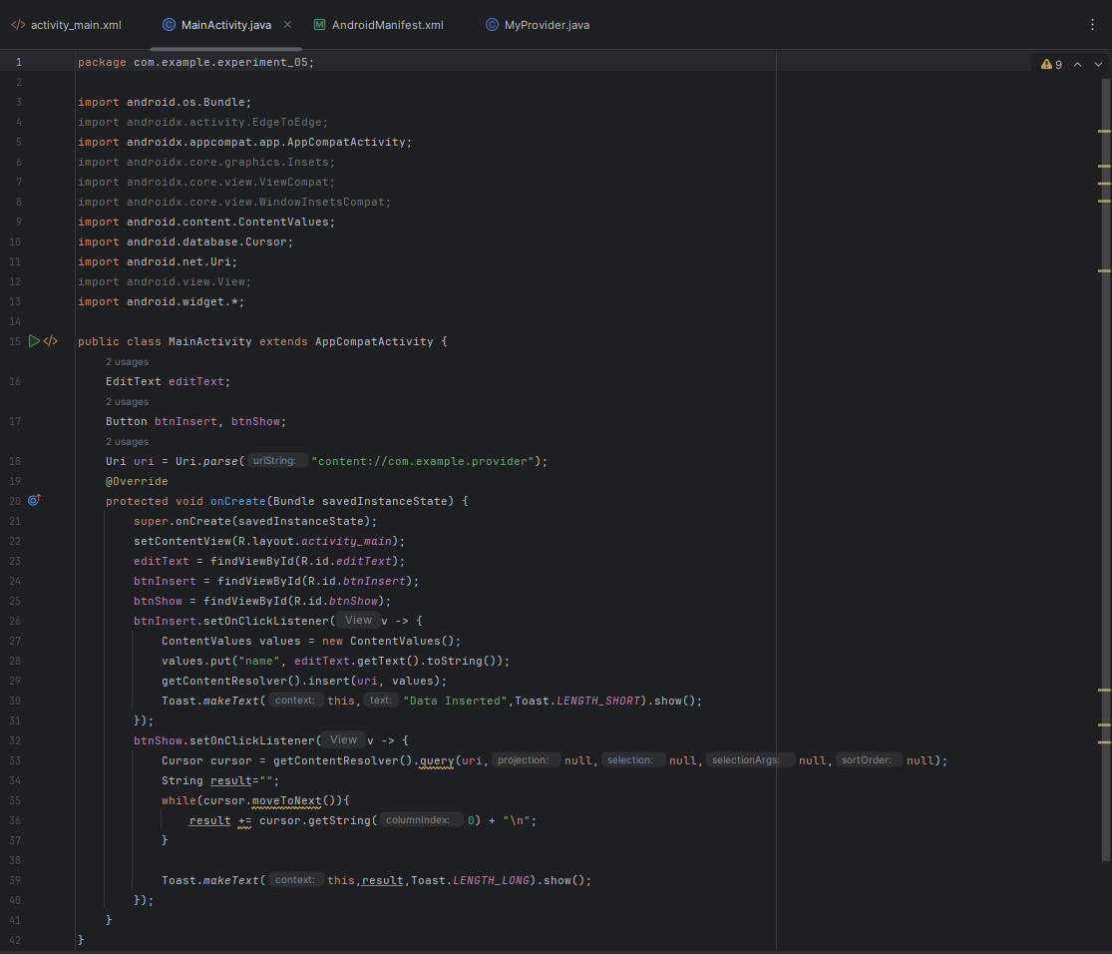
AndroidManifest.xml
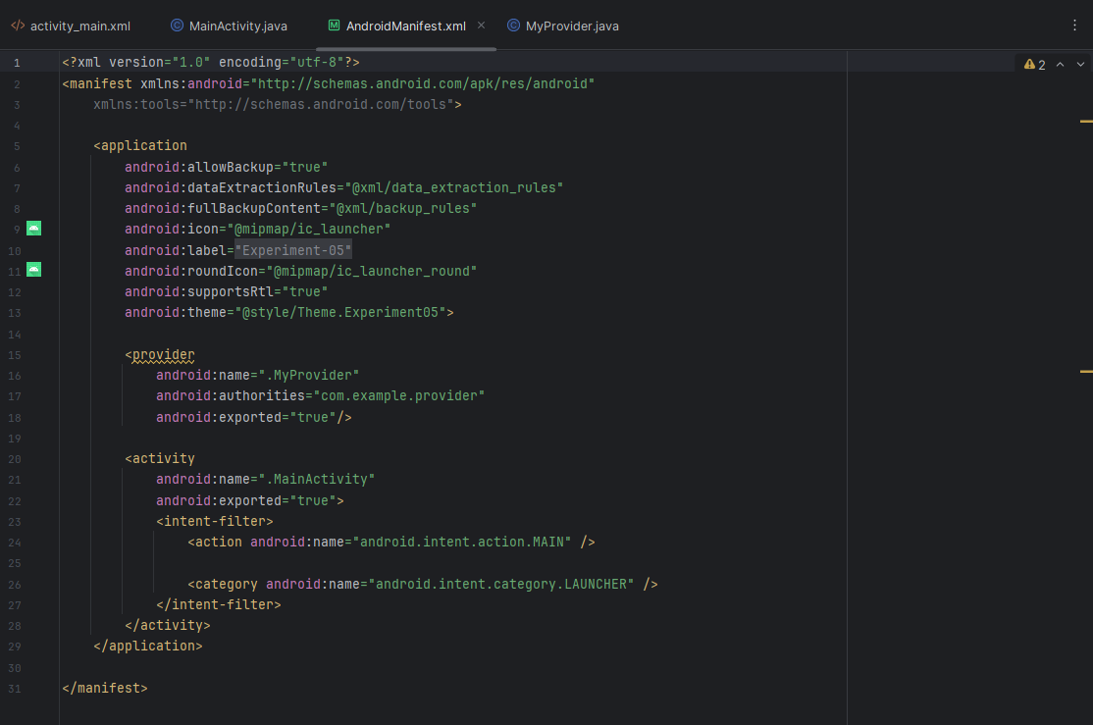

Output:
- Data Storage
  - Names are stored in an internal list inside Content Provider
- Insert Operation
  - User enters name
  - Data is inserted using ContentValues
- Data Retrieval
  - Data fetched using Cursor via query()
- Display Output
  - All stored names shown using Toast message
- Data Management
  - Supports:
○ Insert → add data
○ Query → fetch data
○ Delete → remove all data
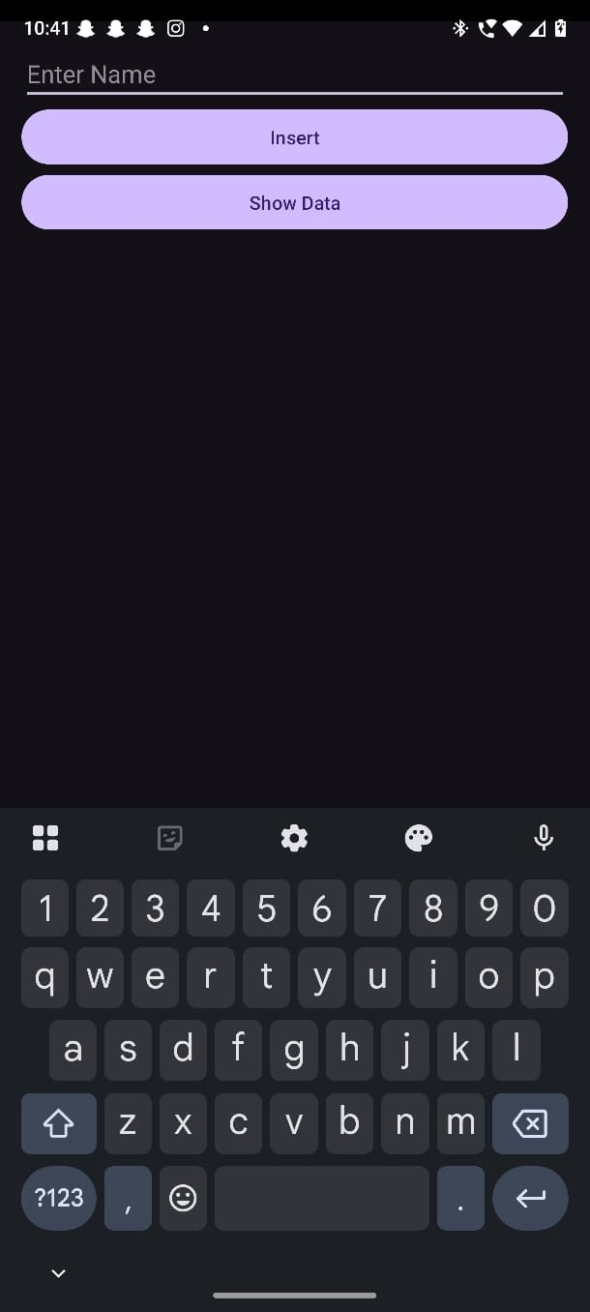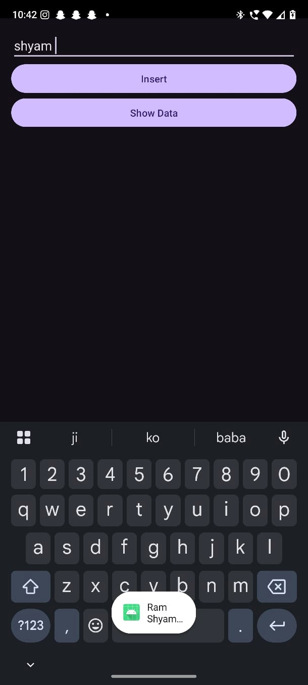

Conclusion:
This practical demonstrates how a Content Provider manages and shares structured data using URIs and allows different components or apps to perform CRUD operations efficiently.

